**PAN STATUS**

**Project Name: Pan Status**

**This Project Main Focused will check Pan Status about to CDSL Share Accounts.**

**The Central Government api url is used to call and get the Pan details.**

**Login Details:**

**Live Server:**

**User Name:** WEBADMIN

**Password:** 037350260D

**Pos Code :** 1600000017

**PassKey: abcd**

**POST MAN Validation:**

**Url:** <https://pancheck.www.kracvl.com/CVLPanInquiry.svc>

**Input Parameters :**

<Envelope xmlns="http://schemas.xmlsoap.org/soap/envelope/">

    <Body>

        <GetPassword xmlns="https://pancheck.www.kracvl.com">

            <!-- Optional -->

            <webApi>

                <password>037350260D</password>

                <passKey>abcd</passKey>

            </webApi>

        </GetPassword>

    </Body>

</Envelope>

**Next Screen Pan Inquiry:**

**The Pan no is available or not in CDSL .**

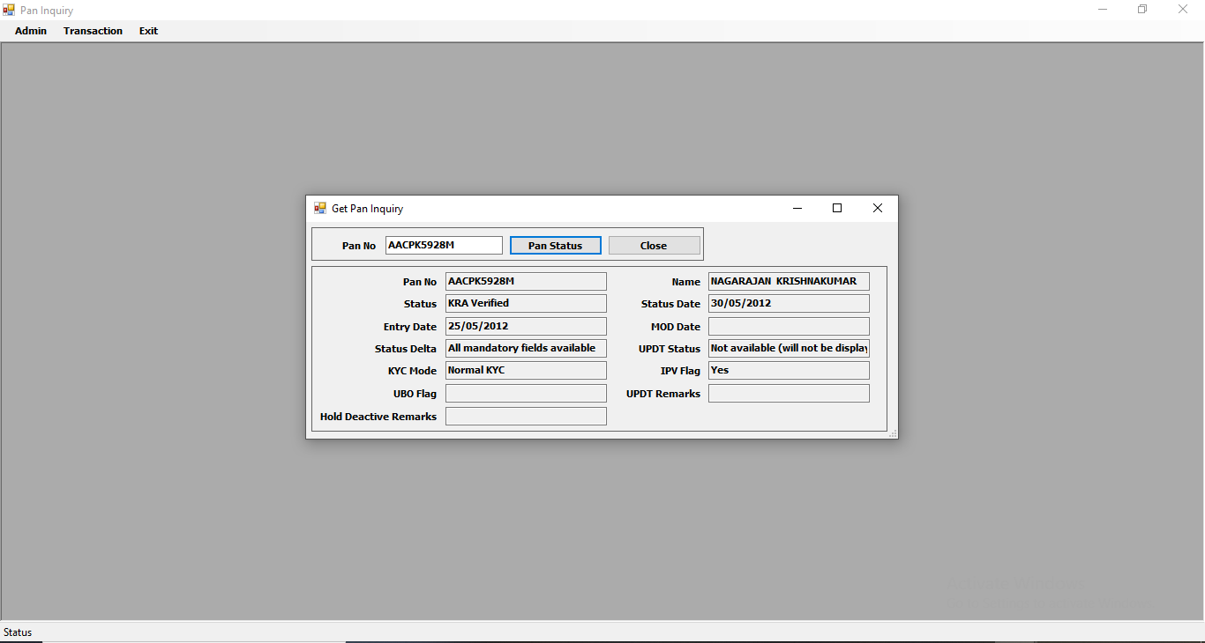

**Post man Validation :**

**URL :** <https://pancheck.www.kracvl.com/CVLPanInquiry.svc>

**Input Parameters:**

<Envelope xmlns="http://schemas.xmlsoap.org/soap/envelope/">

    <Body>

        <GetPanStatus xmlns="https://pancheck.www.kracvl.com">

            <!-- Optional -->

            <webApi>

                <pan>AACPK5928M</pan>

                <userName>WEBADMIN</userName>

                <posCode>1600000017</posCode>

                <password>SQFO3Eyw3XFWwyGbBSDh2w!3d!3d</password>

                <passKey>abcd</passKey>

            </webApi>

        </GetPanStatus>

    </Body>

</Envelope>

**Next Screen Pan Inquiry:**

**This Screen will get all data’s about pan no:**

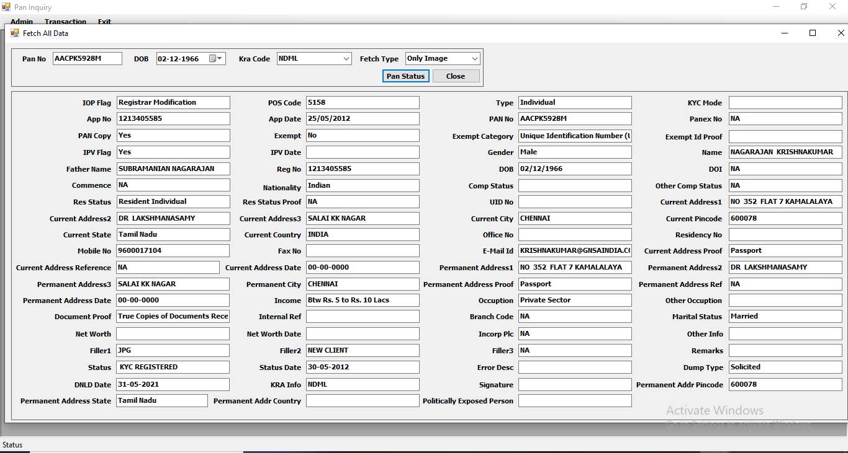

**Post Man Validation :**

**Url:** <https://pancheck.www.kracvl.com/CVLPanInquiry.svc>

**Input Parameters:** <Envelope xmlns="http://schemas.xmlsoap.org/soap/envelope/" >

    <Body>

        <SolicitPANDetailsFetchALLKRA xmlns="https://pancheck.www.kracvl.com">

            <!-- Optional -->

            <webApi>

                <inputXml>

                    <![CDATA[<APP_REQ_ROOT>

                        <APP_PAN_INQ>

                            <APP_PAN_NO>AACPK5928M</APP_PAN_NO>

                            <APP_DOB_INCORP>02/12/1966</APP_DOB_INCORP>

                            <APP_POS_CODE>1600000017</APP_POS_CODE>

                            <APP_RTA_CODE>1600000017</APP_RTA_CODE>

                            <APP_KRA_CODE>NDML</APP_KRA_CODE>

                            <FETCH_TYPE>I</FETCH_TYPE>

                    </APP_PAN_INQ>

                    </APP_REQ_ROOT>]]>

                </inputXml>

                <userName>WEBADMIN</userName>

                <posCode>1600000017</posCode>

                <password>SQFO3Eyw3XFWwyGbBSDh2w!3d!3d</password>

                <passKey>abcd</passKey>

            </webApi>

        </SolicitPANDetailsFetchALLKRA>

    </Body>

</Envelope>

**Source Path:** **\\169.38.77.180\New_volume\Murali\KT\STA\PAN STATUS**